Cover Project Guide Name

Instructions

Fonts
This document uses the Intel corporate font, Neo Sans Intel. To obtain the font, please contact Alison Elmer.
This font comes in a “family” that has different thicknesses. Do not use the bold button in Word to change the font. Instead use the drop down box for the fonts to choose the correct thickness:
- Neo Sans Intel Light is the lightest.
- Neo Sans Intel is thicker.
- Neo Sans Intel Medium is the thickest.
Styles
This document has been set up to use styles. The pages that follow show the styles you should use for the Basic Course and for the Activity Cards. At the beginning of each line is the name of the style used. You may also refer to the guidelines for the style names.
Please use these styles instead of creating your own. This will help create consistent work, allowing for ease in collaboration.
Tips
Intel® Easy Step Text Treatment
The Intel® Easy Steps text treatment is artwork and cannot be edited.
If you need to localize it, use Neo Sans Intel font in white for the cover. Ust the custom RGB color 0/124/146 for the top of the page. You may also contact Alison Elmer.
Show Hidden Formatting
This document uses section breaks and page breaks to aid in formatting the information displayed at the tops of the page. To prevent accidentally deleting this formatting, please display the hidden formatting.
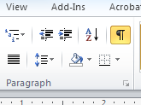
In Word 2010 and Word 2007, click the paragraph icon in the Home tab.
Word 2010
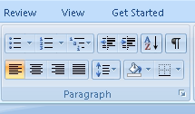
Word 2007
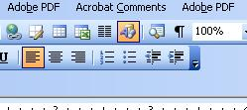
In Word 2003, be sure the standard toolbar is displayed. Then click the paragraph icon.
Word 2003
Headers
The first page of a section has a graphic treatment. It does not use the header feature in Word. The graphic elements are grouped together. If you click on the white text, you can edit it. To copy or move the entire graphic treatment, you must select the graphic element plus the text box.
Different headers should appear on the pages following a new section. These use the header feature in Word.
To create the header, double-click an existing header in this template. This opens the header editor. Copy the contents of the header and paste it into the header area of the new section. Click on Link to Previous in the header tab (Word 2010 and Word 2007) to turn off the connection to the first page of the section because it has the graphic treatment. This will make the first page of a section diffenent from the rest of the pages in the section..
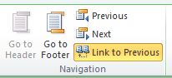
Word 2010, showing “Link to Previous” – click on this to turn off the connection between headers
in different sections
For Word 2003, double-click an existing header, and a palette will appear. This opens the header editor. Copy the contents of the header and paste it into the header area of the new section. Click on the icon shown below to turn off the conenction to the first page of the section.
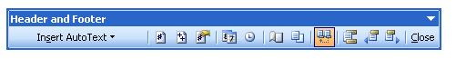
Word 2003 has a Header and Footer palette. Click on the icon that is highlighted to turn off the connection between headers in different sections

Section Breaks
In Word 2010 and Word 2007, when you end a section, go to the Page Layout tab. Select Next Page under Section Breaks. This will set up the next section so you can copy the graphic treatment for the first page of the new section.
After creating the first page of the new section, create another section break to set up the section for the headers on the following pages.. Follow the steps for creating headers in the instructions on the previous page.
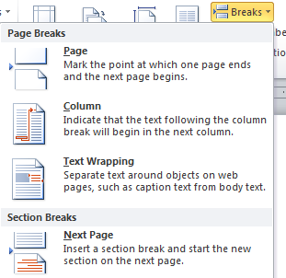
Adding a section break with Word 2010
In Word 2003, when you end a section, go to the Insert menu and select Breaks. Then select Next Page Continuous under Section breaks types. This will set up the next section so you can copy the graphic treatment for the first page of the new section.
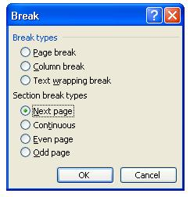
After creating the first page of the new section, create another section break to set up the section for the headers on the following pages.. Follow the steps for creating headers in the instructions on the previous page.
Adding a section break with Word 2003

Converting Activity Cards using Verdana with Word 2010
If you have an Activity Card that was created with Verdana, use the following steps to convert it to this template and
Neo Sans Intel:
- Save the template as a new version
- Show hidden formatting (see instructions in template)
- Delete the instructions and next 2 pages (they represent a basic brochure)
- Copy and paste the text from the Activity card formatted in Verdana, one piece at a time – e.g. just the program description, then just the headline
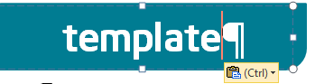
- Each time you paste, note the icon that appears – select “Keep text only”
Icon appears after pasting text with Word 2010
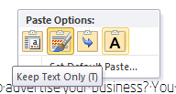
Select the A on the clipboard – this is “Keep text only” in Word 2010
- Use the enter key if pasting removes it. The formatting should stay intact.
- Refer to the styles in the template as needed.
Converting Activity Cards using Verdana with Word 2007 and Word 2003
If you have an Activity Card that was created with Verdana, use the following steps to convert it to this template and
Neo Sans Intel:
- Save the template as a new version
- Show hidden formatting (see instructions in template)
- Delete the instructions and next 2 pages (they represent a basic brochure)
- Copy and paste the text from the Activity card formatted in Verdana, one piece at a time – e.g. just the program description, then just the headline
- Each time you paste, note the icon that appears – select “Keep text only”
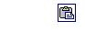
Icon appears after pasting text with Word 2003 and Word 2007
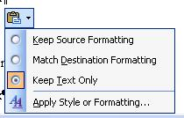
Click the icon and select “Keep text only” from the options
- Use the enter key if pasting removes it. The formatting should stay intact.
- Refer to the styles in the template as needed.

Project Descript

Section Head Module 1
Head 1Introducing Computers and Operating Systems
Intro Body Text Description: Computers have become an important part of everyday life in today’s world. Many people use computers to keep records, do calculations, search information, store pictures and music, play games and communicate with others.
Body-Text Computers have changed the way we work and live. This course is designed to help you develop new skills which will engage you to use a computer to communicate; solve problems; and research, collect, organize and share information. The course provides you many hands-on experiences to explore and discover basic computer applications.
Sub-head 1 Activity 1: Introducing Yourself
Body-Text In this activity, you will have an opportunity to introduce yourself and meet other participants. On the lines below, you can list the key points you want to share with others, such as your name, occupation, interests and an interesting fact about yourself.
________________________________________________________________________________________________________________________________________________________________________________
Sub-head 1TOC – Overview 1
List Head Part 1 – Learning New Skills
List_Sub-Indent Module 1: Introducing Computers and Operating Systems 1.1
List_Sub-Indent Module 2: Introducing Internet and Email 2.1
List_Sub-Indent Module 3: Introducing Word Processing 3.1
Sub-head 1Using Typing Keys
Body-Text In addition to letters, numerals, punctuation marks, and symbols, the typing keys also include SHIFT, CAPS LOCK, the TAB key, ENTER, the SPACEBAR, and BACKSPACE.
Body-Text Bold Centered Key Name | Body-Text Bold Centered Key Image | Body-Text Bold Centered Function
Body-Text Bold  Name here |  | Table Style Press SHIFT in combination with a letter to type an uppercase letter. Press SHIFT in combination with another key to type the symbol shown on the upper part of that key.

Section Head Appendix
Head 1Internet Safety Guidelines
Body-Text Privacy is important. When you interact on the Internet, you may have to give out personal information. You have the right and the opportunity to decide who has access to your personal information, and how that information is uses. It’s also important to protect yourself.
Sub-head 1Be Aware of Who Can See Your Information
Body-Text You should be aware that when you interact on the Internet, particularly if you register to use a Web site, create an email account, a chat messenger account, public blog or wiki, or join a social network, there are many people who might have access to the information that you show online.
Lead In Advertisers: Body-Text The internet is typically used by people or companies that want to sell you something.
Section Head Module 1
Sub-head 1Activity 4: Introduction to Operating System
Body-Text Whenever you turn on the computer, the operating system, which is the most important program in the computer, starts automatically.
Body-Text In this activity, we will explore Ubuntu OpenOffice.*
Sub-Head 3 Step 1: Turn on the Computer
Body-Text Turn on your computer by pressing the Power On button on the computer. When you turn on the computer and the operating system has finished loading, the computer’s Desktop is displayed on the monitor.
Sub-Head 3 Step 2: Learning about Desktop
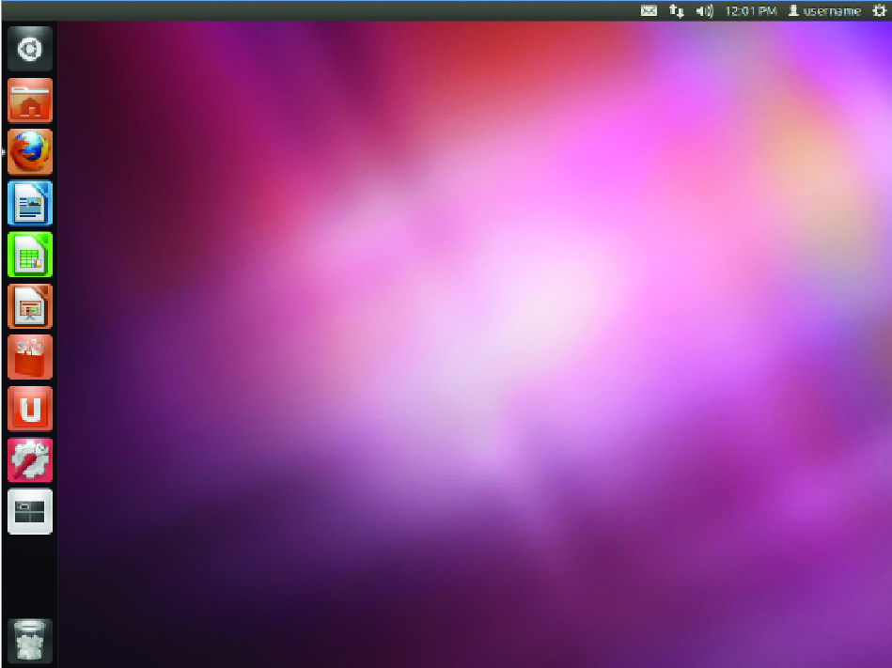
Body-Text After you turn on the computer, the monitor will display a main image on the screen. This is called the desktop. The desktop is so named because it functions like a “virtual” disk workspace; it has a place to work, a place to file documents, and is the location of various tools to help you complete your tasks.
Help Guide Ref. For help, see Word Processing Skill 1.1: To start word processing software
Photo Caption Screenshot Example

Description

Head 1 Create a Brochure
Sub-head 1Advertise your business
Intro Body Text Have you ever needed an easy and inexpensive way to advertise your business? You can create a brochure which is a small leaflet or pamphlet often containing product or service information. In a business, brochures are used to introduce and advertise products or services to potential customers.
Body-Text Quisque porta vestibulum massa, sed commodo neque viverra pulvinar. Sed pharetra sodales risus eget rutrum. Aenean orci odio, feugiat eu convallis vel, rhoncus at elit. Etiam lacinia sodales lorem vitae euismod. Morbi ornare enim et tellus varius ac lobortis elit pellentesque.
Example Headline Look at the following example:
Photo Caption Brochure Page 1 Example
Photo Caption Brochure Page 2 Example
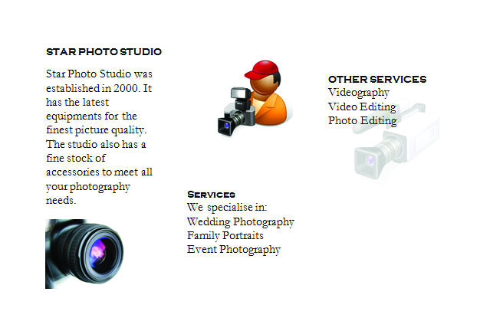

Body-Text As in the example above, a Brochure created on the computer typically:
- Body_Bullet List Is made using a single sheet of paper that is printed on both sides and folded (tri-fold). It is set up in columns.
- Body_Bullet List Contains information about the products and services offered by the business
- Body_Bullet List Incorporates pictures that help make the written information clear or attractive to the potential customer
Sub-head 1Advertise Products
Body-Text Before you being using the computer to create your brochure, take a moment to get familiar with the Intel Program style Intel® Education Help Guide. The Help Guide provides handy step-by-step instructions for common applications right as your work.
Sub-head 1Steps on How to Create a Brochure
- List_Alpha Set The Page To Landscape
- List_Sub_Numeric Start the word processing software, and open a new, blank document
Help Guide Ref. Indent For help, see Word Processing skill 1.1: To start word processing software
- List_Numeric Aliquam nisi arcu, porta et iaculis vel, venenatis ac lectus.
- List_Sub-Alpha Aliquam nisi arcu, porta et iaculis vel, venenatis ac lectus.
Note style Note: Etiam lacinia sodales lorem vitae euismod. Morbi ornare enim et tellus varius ac lobortis elit pellentesque. Duis adipiscing fermentum erat vitae convallis.
Sub-head 1Contents (T.O.C.)
Contents (TOC) Address Book 1
Contents (TOC) Brochure 2

