How Do You Measure Up?

Estimate your measurements in metrics, and then use a tape measure to find your actual measurements.
Height _______est.
_______actual
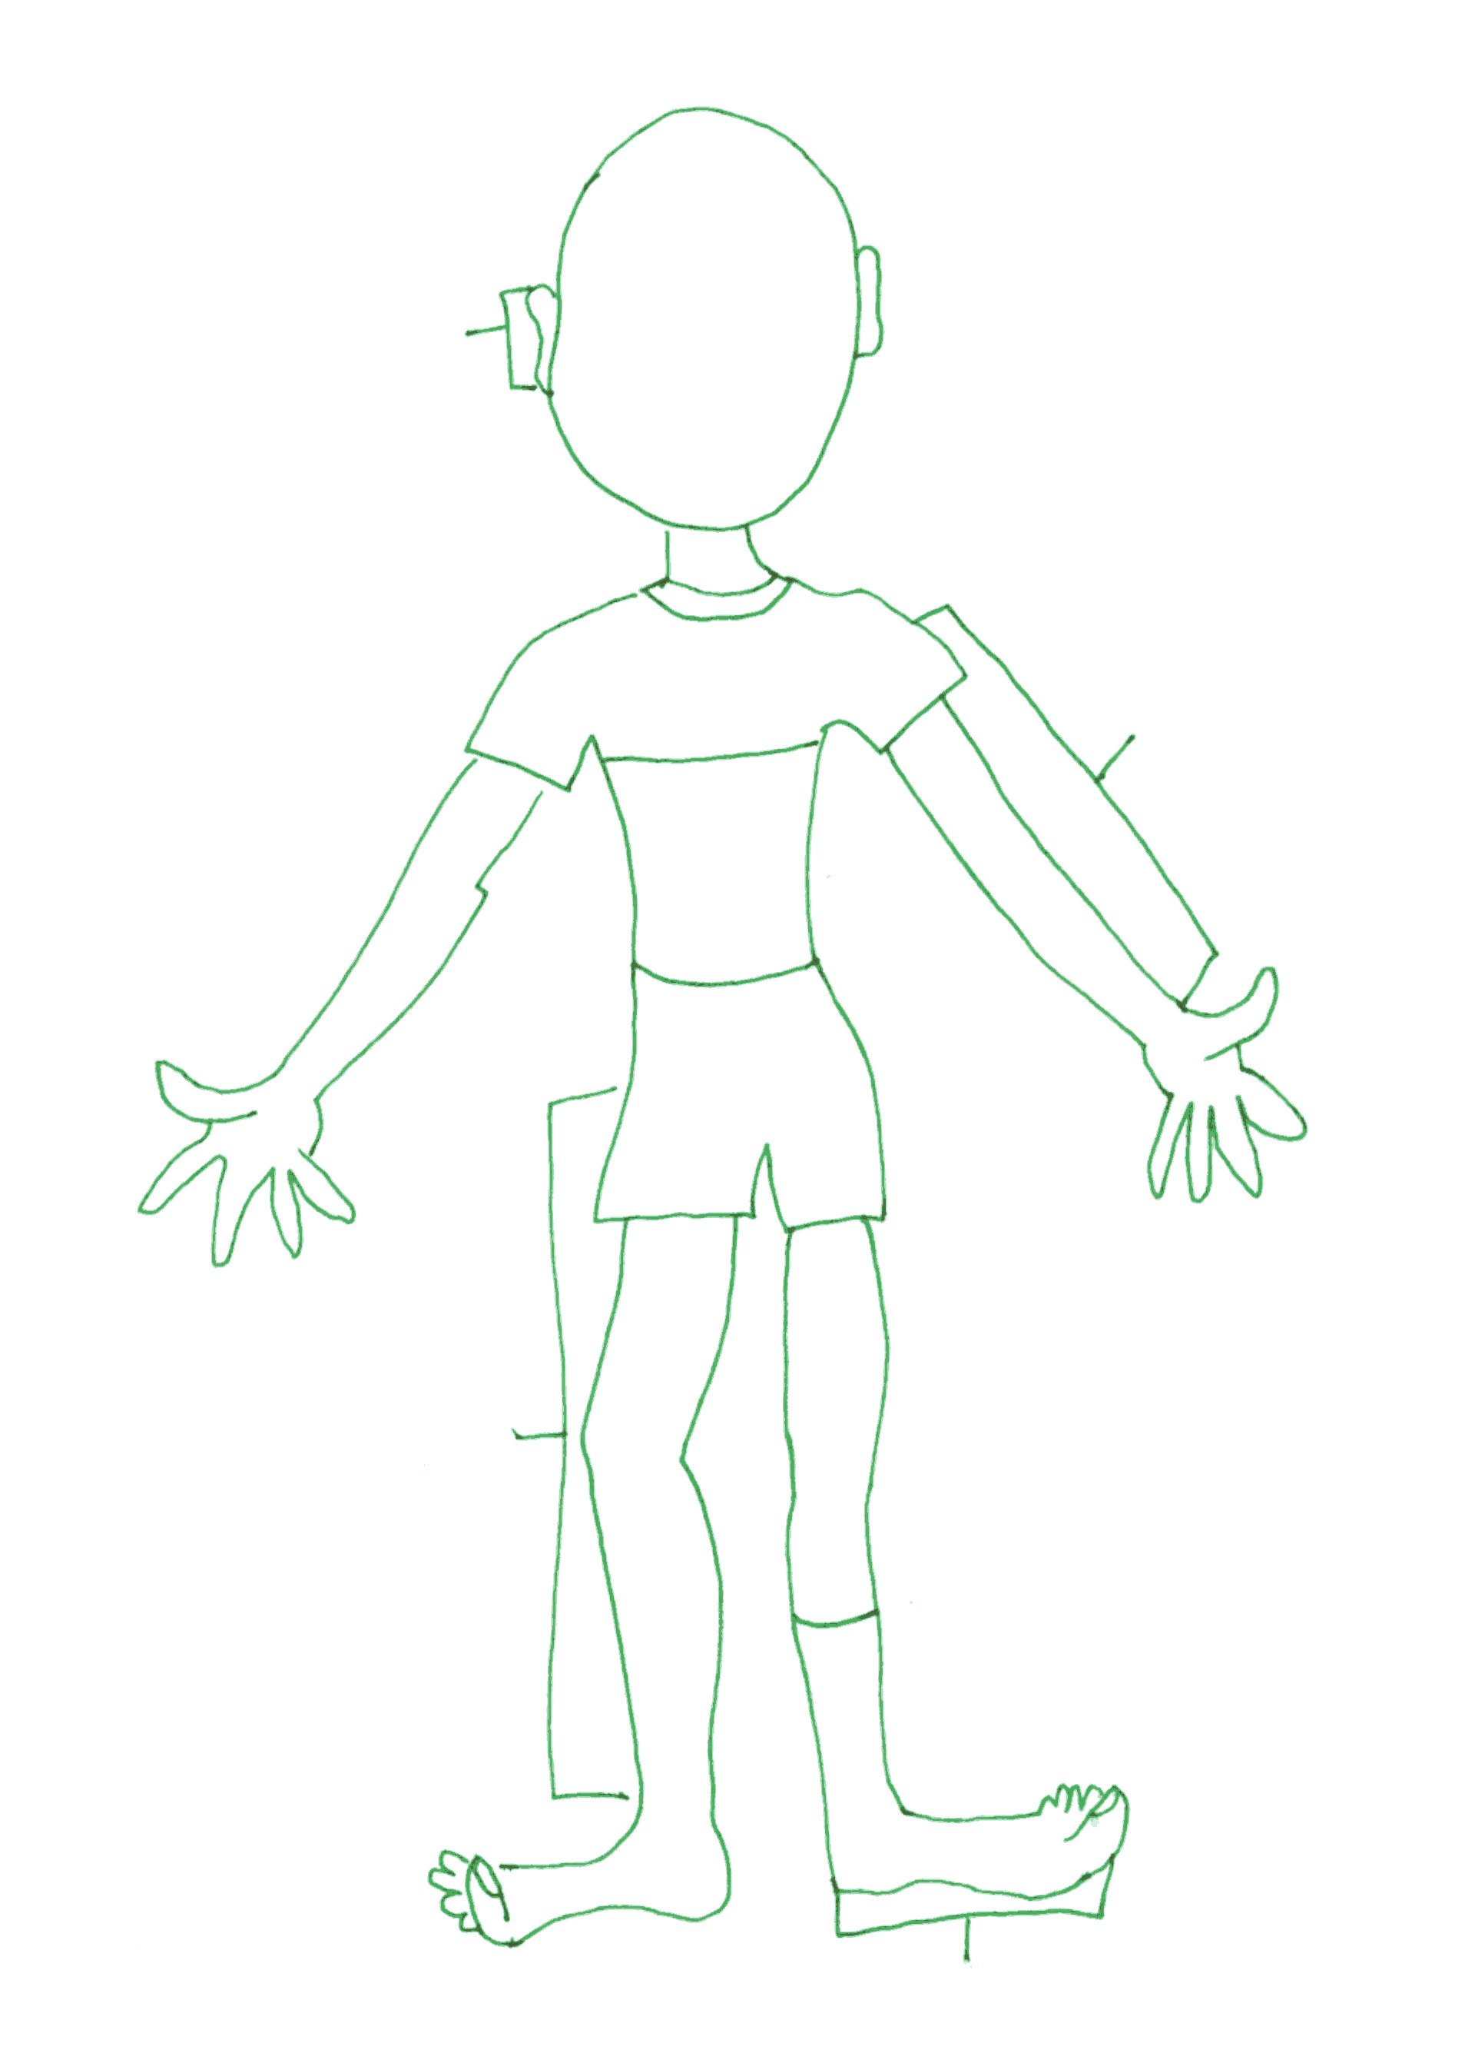

Arm length _________ est.
_________ actual

Around Head _________est..
_________actual
Smile _________ est.
_________ actual

Around Neck _________ est.
__________actual
Thumb length _______est.
_______ actual
Around little finger _______est.
_______ actual

Width of calf _______est.
_______actual

Big Toe length ______est.
______actual
Length of Foot _______est..
_______actual

Around Big Toe
_______est.
_______actual

Leg Length _______est.
________ actual

Waist ______est.
_______ actual

Ear length ______est.
______actual
Nose length _____est.
________actual

