Tutorial for wik.is

This document includes the steps and suggestions for setting up a wiki site for the Intel® Teach Essentials Course or your own personal classroom. These instructions apply to the MindTouch* wik.is site (www.wik.is). Setup will be similar on other wiki sites, but features and specific instructions will vary.
For other questions, visit the wik.is FAQ at: http://help.wik.is/FAQ
Registering for a Wiki

- Obtain e-mail addresses for your students or course participants.
- Go to: www.wik.is
- Click the button to start your wik.is.
- Enter the site name you want for your course or class.
Note: Make the site name unique to you, your school, or your class since it becomes a part of the URL.
- Enter your e-mail address.

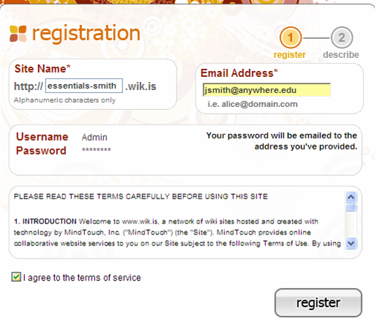
Step 4: Enter a name for your wiki (a sample is provided).
Step 5: Enter your e-mail address.
Note your user name as the administrator of this wiki. Your password will be e-mailed to you.

Step 6: Click the checkbox.
Step 7: Click the register button.
- Click the checkbox to agree to the terms of service.
- Click register.
- Check your e-mail for the logon information.
- Click the link within the e-mail message to activate your wiki.
- Click go to my wiki.
- Log on to your wiki using the password provided in the e-mail.
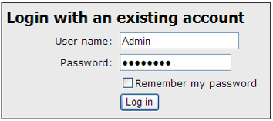
Changing Your Password
- To change your password, click the Tools menu, and then click My Preferences.
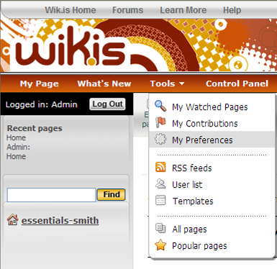
Step 1: Click My Preferences.
- Click My Password and enter your old password and your new password twice.
- Click Apply preferences.

Editing Your Wiki’s Home Page
Your first task after setting up your wiki is to edit your wiki’s home page and replace the default text with your own text. Showing your own text reassures users that they are in the right place as well as gives users guidance for using the wiki.
- Click the link for the home page of your wiki in the left navigation pane.
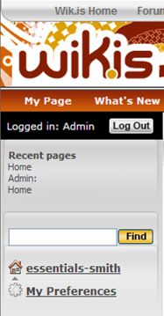
Step 1: Click the name of your wiki to go to your home page.
Note: The name of your wiki will be different from the one listed here.
- Click Edit page.
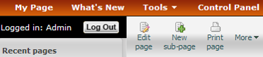
Step 2: Click Edit page.
- Click anywhere on the placeholder text box to select it.
- Press the Delete button on your keyboard to delete the text.
- Type a welcome message for your course or class. If this is for your Essentials Course, copy and paste the text available from the “Setting Up a Wiki Site for Your Course” document located in the Training Community Resources > Prepare for Course.
Note: The title on your wiki’s home page cannot be edited because it is associated with your wiki’s URL.
- You can use the Style list box to change the style of the text. Select the text you want to change and then select a style in the list box.
Step 7: Click the Save and Exit button the first time you save.
Step 6: Select a style in the Style list box to change the font style.
Note the Save without exiting button.
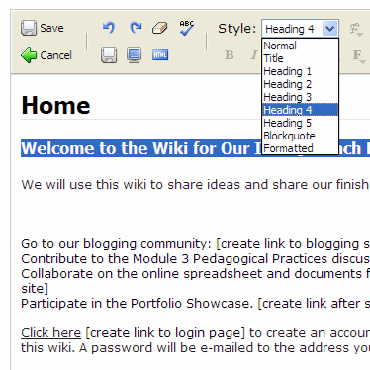
- Click the top left Save and Exit button. This save button closes edit mode, but it must be used the first time you save a page.
Note: You can click the Save without exiting button located on the second row in the toolbar in the future when you want to save your work but continue working on your page.
- Click the Edit page button to return to edit mode and continue working on your welcome message.
- Use the Save without exiting button frequently while you work so that you will not lose work if your Internet connection fails.
- Click the top-left Save and Exit button to save and exit when you are done.

Creating Sub-pages
- Click New sub-page.
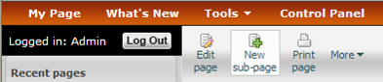
Step 1: Click New sub-page.
- Select to highlight the Page Title text and then type your own.
Note: The page title will become a part of the wiki URL for this page, so keep the title short.
- Click the top-left Save and Exit button to save and exit.
- Click the Edit page button to return to edit mode. Delete the placeholder text and create the text for the body of the sub-page. If this wiki is for your Essentials Course, copy and paste the text available from the “Setting Up a Wiki Site for Your Course” document located in the Training Community Resources > Prepare for Course for the appropriate sub-pages, such as Module 2 Pedagogical Practices.
- Format the text as desired. For example, add boldfacing, bullets, or color.
- If the format of pasted text is not what you want, use the Clear formatting button to eliminate formatting code that is creating undesired results.
- Use the Save without exiting button frequently while you work so that you will not lose work if your Internet connection fails.
- Click the top-left Save and Exit button to save and exit when you are done.

Creating Hyperlinks to a Web Site
- To create a link to another Web site, select the text that you want to hyperlink.
- Click the Insert/modify link button (the blue underlined L) on the toolbar.
Step 2: Click the Insert/modify link button.

Step 3: Type or paste the URL.

Step 4: Click Make link.
- Paste or type the URL into the Link box.
- Click the Make link button.
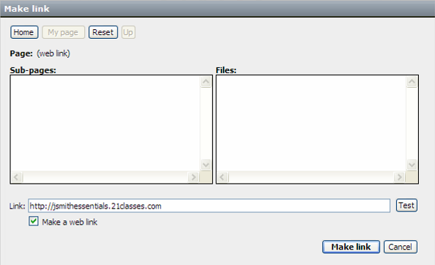
Creating Hyperlinks to a Page in Your Wiki
Although the left-hand navigation is almost always present, you may want to provide links to internal wiki pages in the body of your home page so that you can provide context. Use the following instructions to create a link to a page in your wiki.
- Select the text that you want to hyperlink.
- Click the Insert/modify link button (the blue underlined L) on the toolbar.
- Select the desired sub-page listed in the box. The link information will automatically be inserted in the Link text box.
- Click Make link.
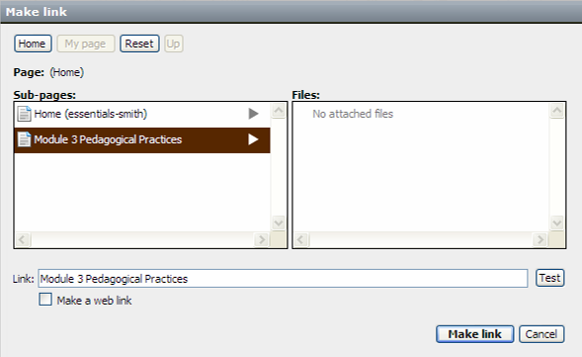

Step 3: Select the desired sub-page.

Step 4: Click Make link.
- On your wiki’s home page, you may want to link to the logon page where your participants or students can either log on or register to use the site. To do this:
  - Click logout to go to the logon page.
  - Copy the logon page’s URL. It will be unique to your wiki.
  - Log on to your wiki as the admin.
  - Edit the home page and create a link to the logon page.

Attaching a File or Image
Before you can link to a file or insert an image into the body of your page, you have to attach—or upload—the file. All files uploaded to a particular page will appear at the bottom of the page; therefore, you may not need to provide an internal link to the file as well, unless you want to provide context or additional instructions. To attach a file or image:
- Go to the wiki page where you want the file or image to appear.
Note: You cannot be in edit mode when attaching a file.
- You can attach a file in either of the following two ways:
  - On the More menu, select Attach file or image
  - Click the Attach file or image link at the bottom of any of your wiki pages
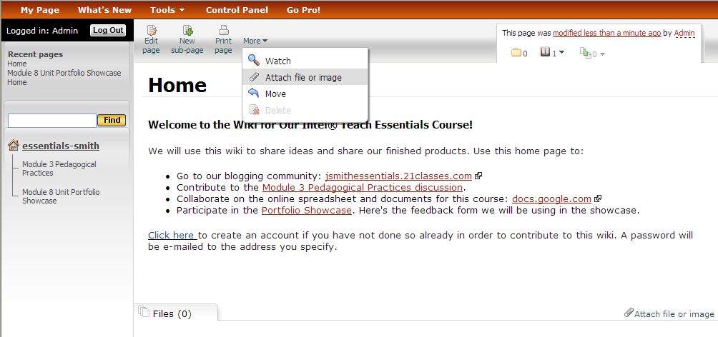
Step 2: Select either method to upload a file.
- Click Browse, locate the file on your computer, and then click Open.
- Type a description of the file, if needed.
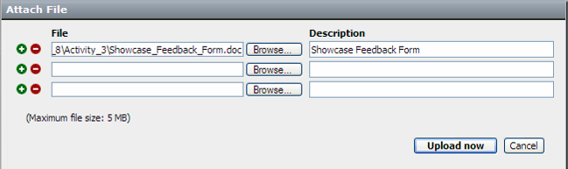
Step 4: Type a description of your file.

Step 5: Click Upload now.
- Click Upload now. After the file is uploaded, it will be listed at the bottom of the wiki page.
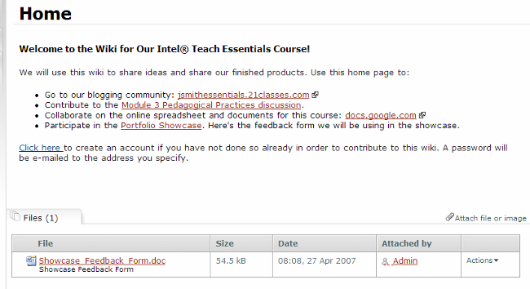
Uploaded files appear at the bottom of the page.
- If desired, you can create a link to the uploaded file. To do this:
- Click the Edit page button.
- Select the text that you want to hyperlink.
- Click the Insert/modify link button (the blue underlined L) on the toolbar.
- Select the file from the right-hand side. The link will automatically be created.
- Click Make link.
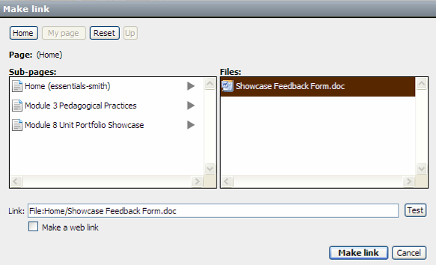
Step 6d: Select a file

Step 6e: Click Make link.
Inserting an Image
Before you can insert an image into your wiki, you must attach—or upload—the file to your wiki. (See the preceding section, “Attaching a File or Image.”) After the image file is uploaded, you can insert the image into the wiki page.
- Click the Edit page button for the page where you want to insert the image.
- Place your cursor at the location in the page where you want the image to appear.
- Click the Insert image button.
- Select the desired image name in the middle Files panel. (All uploaded images will be listed.) When you click an image, a preview displays in Preview area.
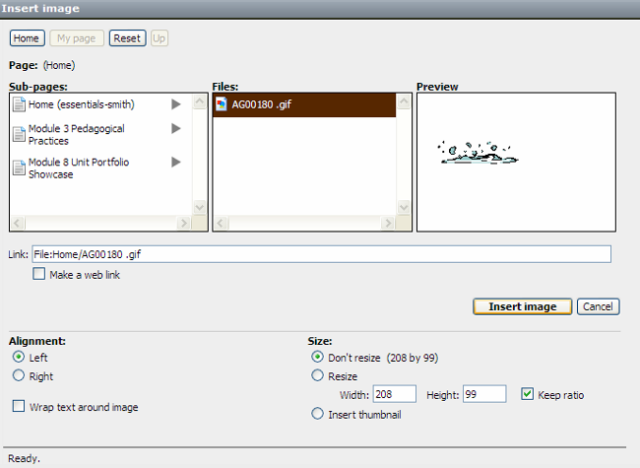
- Make any additional modifications for how the image will appear on the page. For example, you can:
- Resize or automatically size the image to create a thumbnail image (a postage stamp sized image—about the size of your thumb)
- Change the image’s alignment
Change how the image Resize the image.
will appear on the page.
- Control how text flows—or wraps—around the image
- Click Insert image.

Adding Users to the Wiki
It may be easier for your users if you create a login account for them directly. You can create a standardized user name for users, such as one generated by first initial and last name. When you add a user, the wik.is system automatically generates a randomly created password and e-mails it to the user. If the e-mail address does not exist or the e-mail server rejects the e-mail sent by wik.is (in some instances, the wik.is e-mail may be classified as spam), you will be notified. The notification will include a copy of the e-mail that was sent out, which contains the login name and password. In those cases, you may need to provide the login information directly to users. In the case of adding students as users, you may want to intentionally create e-mail addresses that do not exist in order to receive the passwords directly. To add users:
- Click Control Panel.
- Click User Management.
- If your wiki is for a K–12 classroom, you may want to uncheck the box under Account creation settings, which will prohibit people from creating accounts for themselves via the Log In page. If your wiki is for the Essentials Course, keeping the default setting may be helpful.
- To quickly add new users, click the Click here link several times to add another row to the form. This will provide multiple entry boxes so you will be able to submit the new users in batches.
- Add user names using a standardized login format, such as first initial and last name.
- Add corresponding e-mail addresses.
- You might want to add each user’s full name or first name in the Real name box to help identify the users. This field is optional.
Steps 1 and 2: Click Control Panel, and then click User Management.

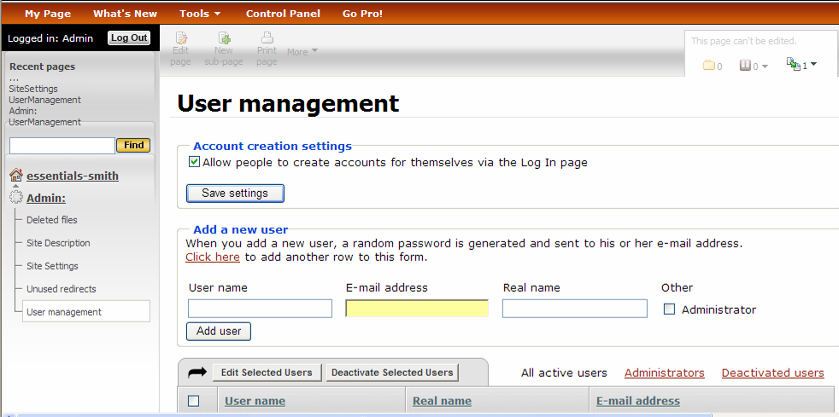
Step 4: Click Click here to add multiple rows to the form.

Step 9: After user information is entered, click Add user.
- If you have a co-facilitator or team teacher(s) who will be helping to administer the wiki, you may want to click the Administrator box when adding them to the site to grant them all management rights.
- Click Add user.

